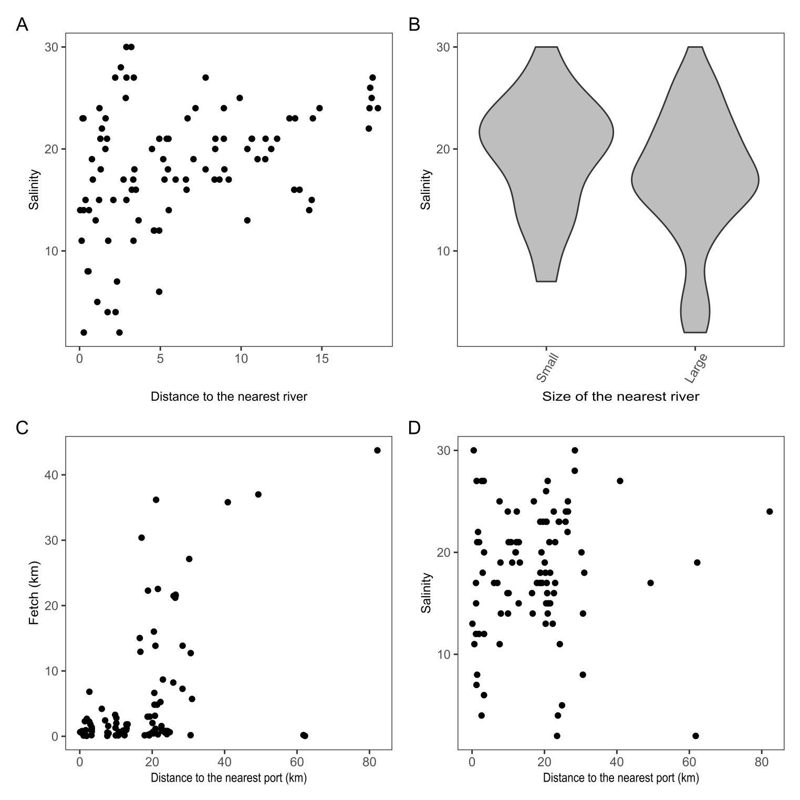

Figure S2. Associations between the environmental parameters. (A) Association of salinity with distance to the mouth of the nearest river. (B) Kernel density violin-plots showing salinity variation for sites near small and large rivers. (C) Association between fetch and distance to the nearest port. (D) Association of salinity with distance to the nearest port.